GRADE :II Revision worksheet Name:
- Write the missing numbers

178 |  |  | 181

II. Fill in the blanks with ‘>’, ‘<’ or ‘=’.
- 123 _______ 149
- 148 ______ 179
- 109______ 190
- 100______ 100

III. Add the following
6 4 4 9
- 3 2 + 1 3
_______ ______
_______ ______

IV. Subtract the following
7 8 8 4
– 3 2 – 1 6
______ _______
______ ________

V. Write the face and place value of the underlined digit
1 9 7
Face value __________
Place value __________
VI. Arrange the numbers in descending order
143 193 138 114
__________________________

VII. Solve the problems and colour using the given colour code
38 - green 46 - red
63- blue 12- pink
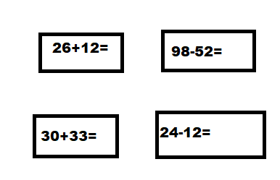
VII. Draw your own picture using horizontal and vertical lines

